Bank NPL Rates by Asset Size
Problem Statement: Non-performing loan (NPL) rates vary widely across banks and are a core credit-risk and asset-quality metric. This analysis investigates whether bank size (measured by total assets) is associated with higher or lower average NPL rates, using data on 158 banks.
Solution Strategy: 1) Extract the NPL-rate vector and compute its quartiles + histogram. 2) Compute the median of total assets and split banks into small (≤ median) and large (> median) groups. 3) Compare the NPL quartiles and histograms of the two groups. 4) Quantify the gap with IQR, means/medians and Spearman correlation; run a Monte-Carlo simulation under noise and alternative split thresholds.

Solution
Overall NPL quartiles: Q1 = 7.44 %, Median = 8.96 %, Q3 = 10.18 % (range 2.74–15.68 %).
Median total assets threshold: ≈ $3,488 million.
Small-bank NPL quartiles: 2.74 / 8.00 / 9.69 / 10.67 / 15.68 (median ≈ 9.69 %).
Large-bank NPL quartiles: 3.97 / 7.18 / 8.49 / 9.53 / 15.17 (median ≈ 8.49 %).
Key contrast: Large banks report ~1.2 percentage points lower median NPL than small banks. Spearman correlation assets–NPL ≈ −0.35 (moderate negative association).
A bank with NPL = 9 % sits near the overall median; relative to size groups it is typically in the lower half of the small-bank distribution and the upper half of the large-bank distribution.
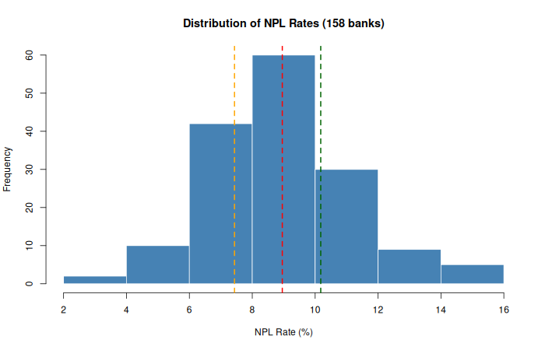
Overall NPL-rate distribution with quartile markers

Key Takeaways
• Larger banks (above median assets) show lower median NPL rates and slightly tighter dispersion than smaller banks.
• The association is moderate (Spearman ≈ −0.35); size alone does not explain all variation in asset quality.
• Monte-Carlo simulation with modest noise still yields a stable positive gap (Small − Large ≈ 1.1 pp, 95 % MC interval roughly 0.65–1.59).
• Audience adaptation: Credit Risk analysts receive exact quartiles and correlation; executives receive the headline gap and one comparative histogram pair.
Files: Practice_Skeleton.ipynb | Solution.ipynb | Cheatsheet | data/bank_data.csv | flowchart & plots

